Web Programming Final Project

Chris Mazurski

Phu Phan

CS 416-01

Professor Williams

12/05/16

Instructions

* A user can make a new account and login by hitting Sign Up, or use their existing account to Log In
* On login, a user receives an updated navbar with options to view/edit user details, and the option to logout and kill the session.
* A user can view products up for sale by hitting the Products button
* A user can find products using the search bar
* Adding products to the cart will update both the number of products and the cost of them in the navbar via AJAX.
* Clicking the cart will allow the user to see exactly which products they’ve stashed for the order, and update/delete them from the cart as they wish
* In order to reach the checkout view, the user must be logged in (and will be sent to the login page if they haven’t done so)
* Checkout will provide the user with a list of exactly what’s in their order (including quantity), and the grand total.
* Logging in via username: [adminuser@adminuser.org](mailto:adminuser@adminuser.org) and password:adminuser will provide extra features in the pages, such as the ability to add,delete, and edit products in the product view, as well as the ability to delete user accounts.

Requirement satisfied:

* 1 to Many: Model Order and Model Order_item. One order can have many Order_Items.
* Business Logic:
  + If User hasn’t logged in, the cart will show the button to log-in. if the User has logged, the cart page will show the button to check out.
  + Only Admin user can perform actions like adding/editing products and deleting users and seeing the list of user.
* Validation: through at the log in and signup process with the User model, and creating new product with Product model.
* Ajax: when adding products from the Product page to the cart, the total price and the number of items will be updated at the top right of the page without refreshing the page.
* Heroku link: https://secure-chamber-75116.herokuapp.com
* Using Bootstrap framework: When shrinking the page, the context will automatically rearrange to fix the page

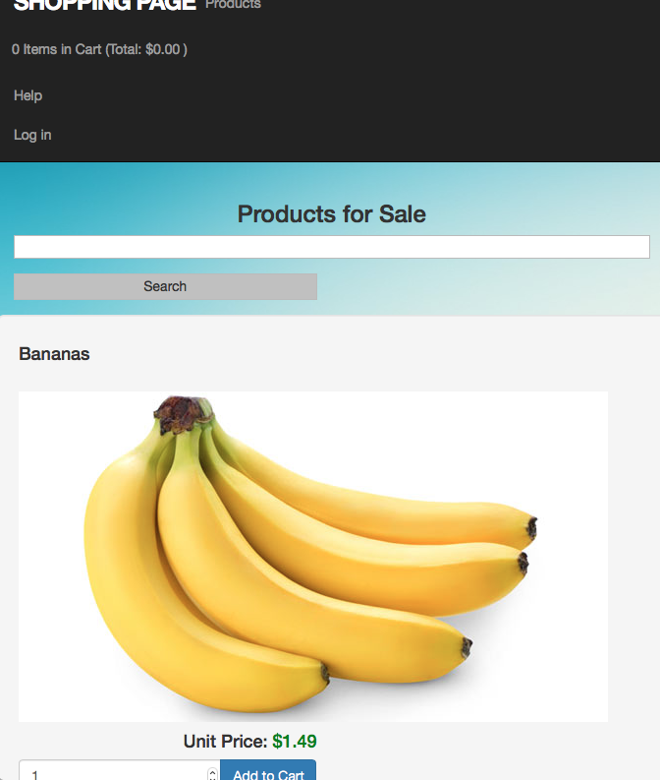

Screen shot:

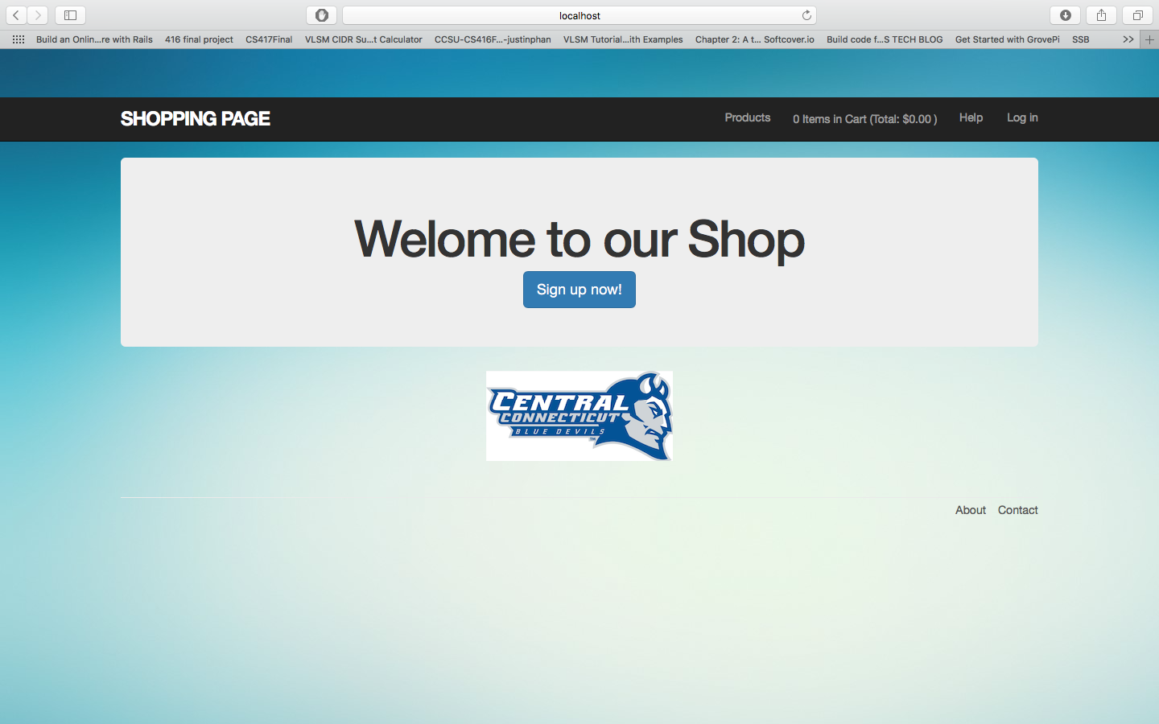

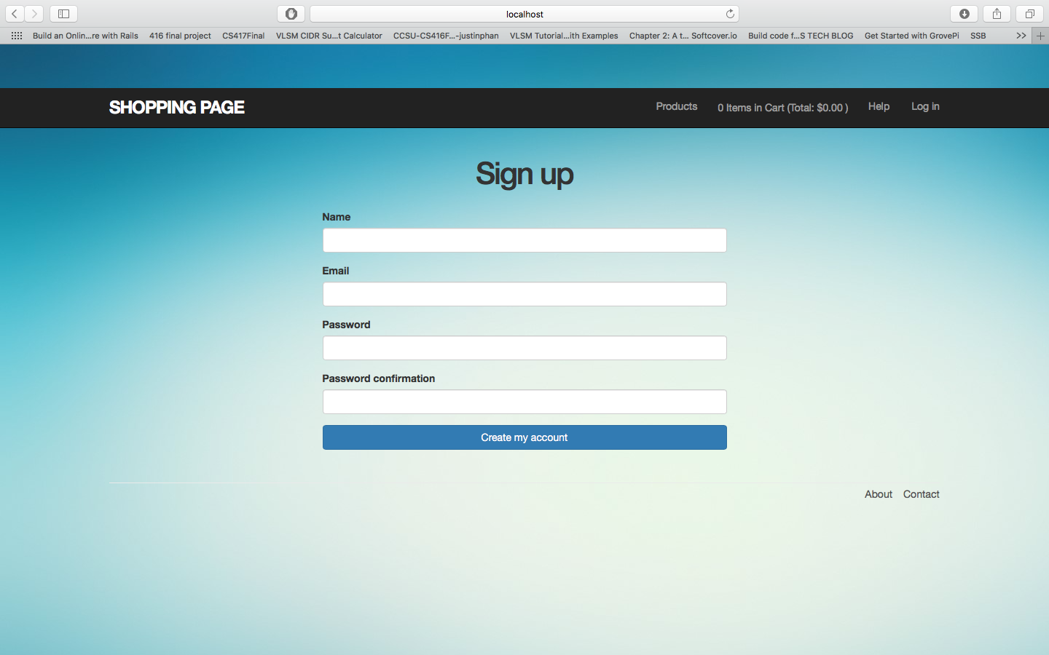

Sign up with bad info: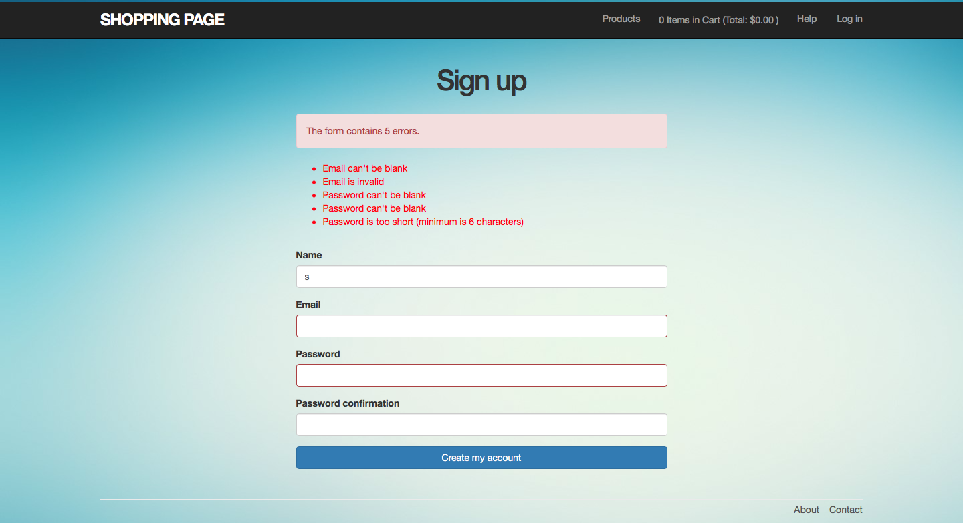

After successful signing up:

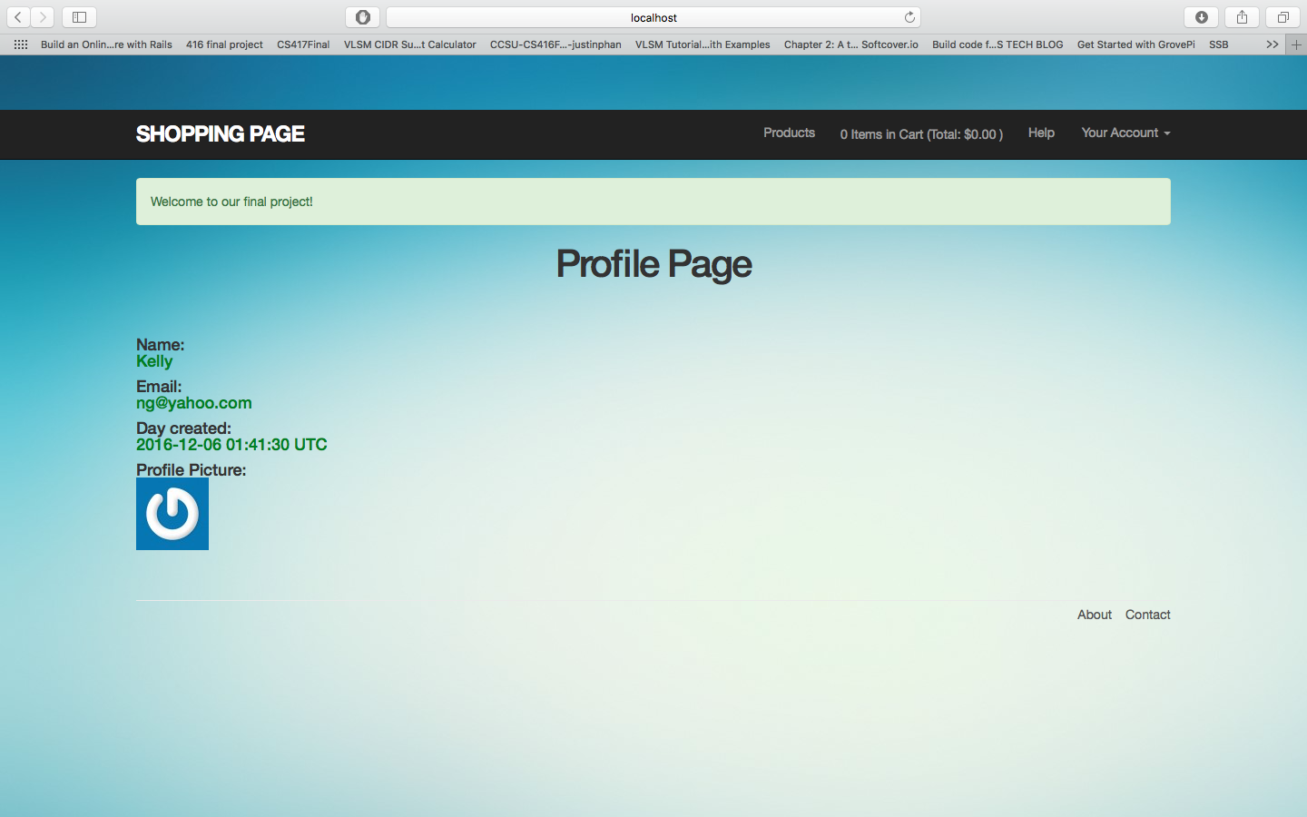

Product Page:

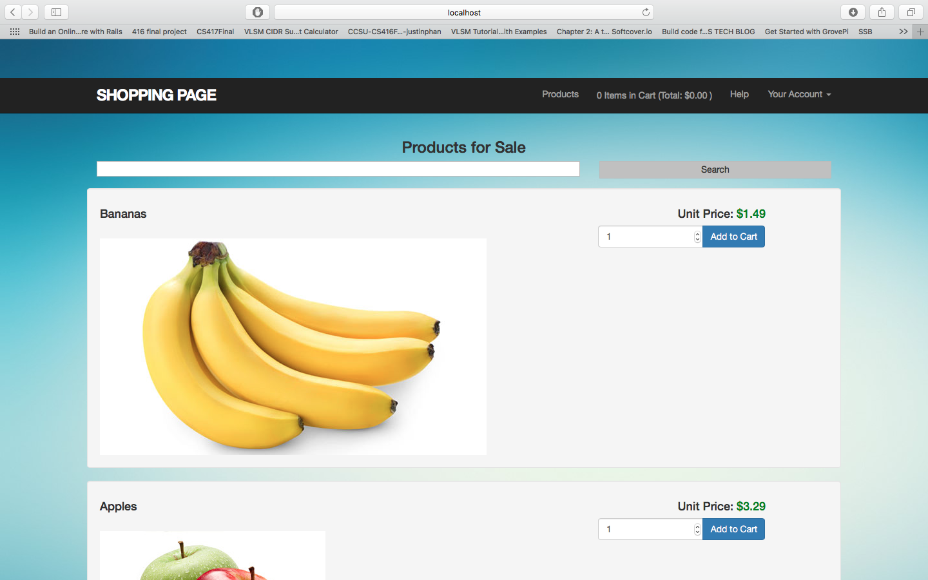

Doing Searching:

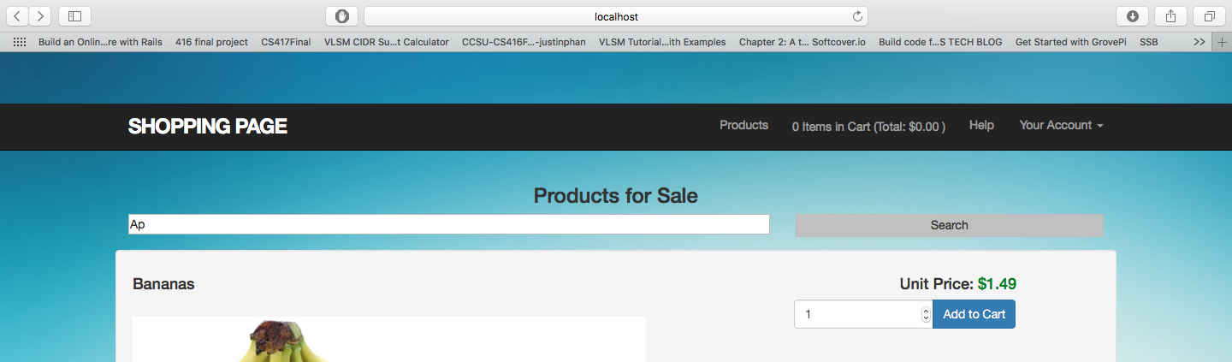

Result:

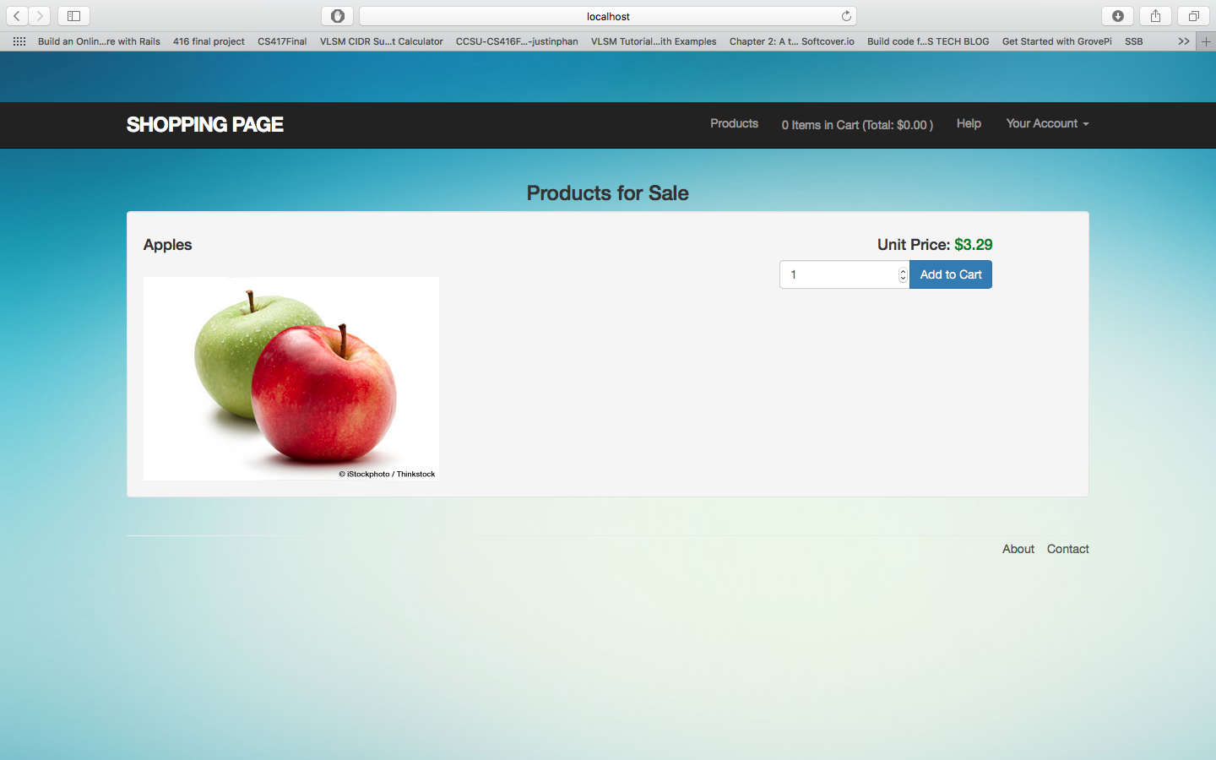

Ajax is used at the top right updating the number of items and the total price

Cart Page:

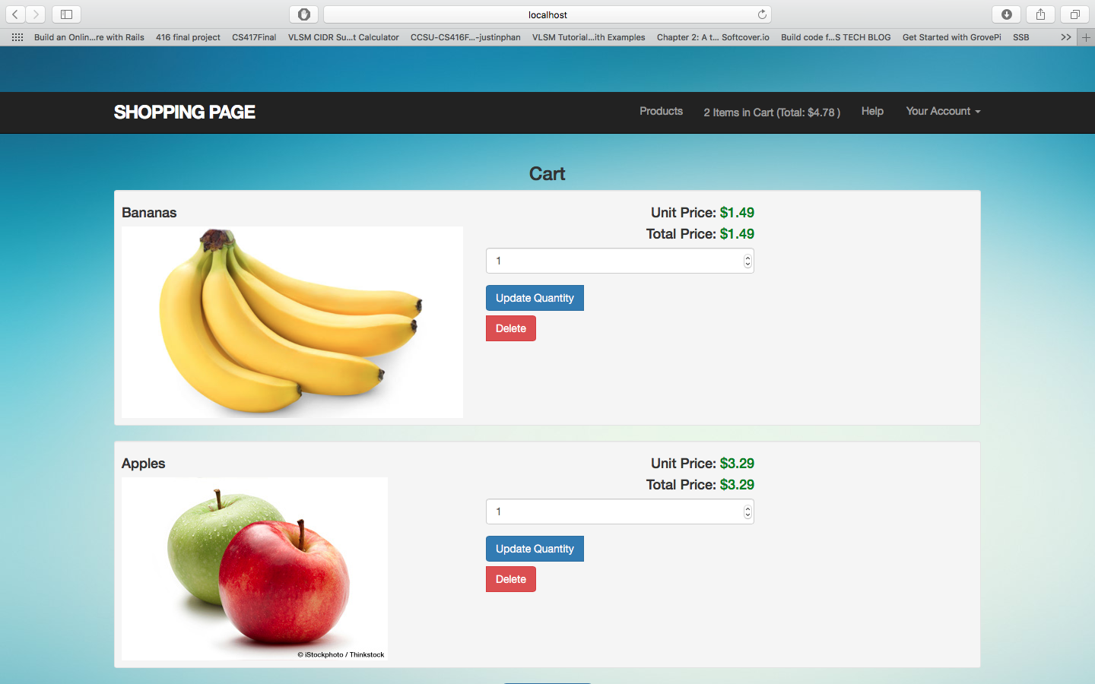

Checkout Page:

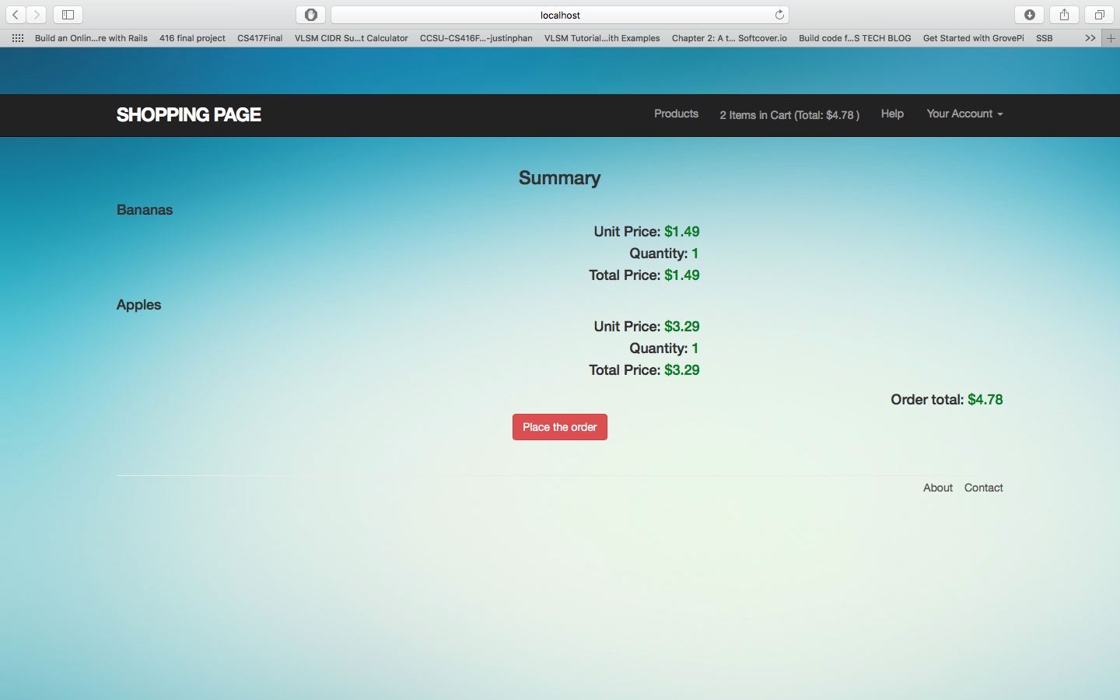

Special Admin views when logging with admin account [adminuser@adminuser.org](mailto:adminuser@adminuser.org) password: adminuser

Admin User is able to edit/add product:

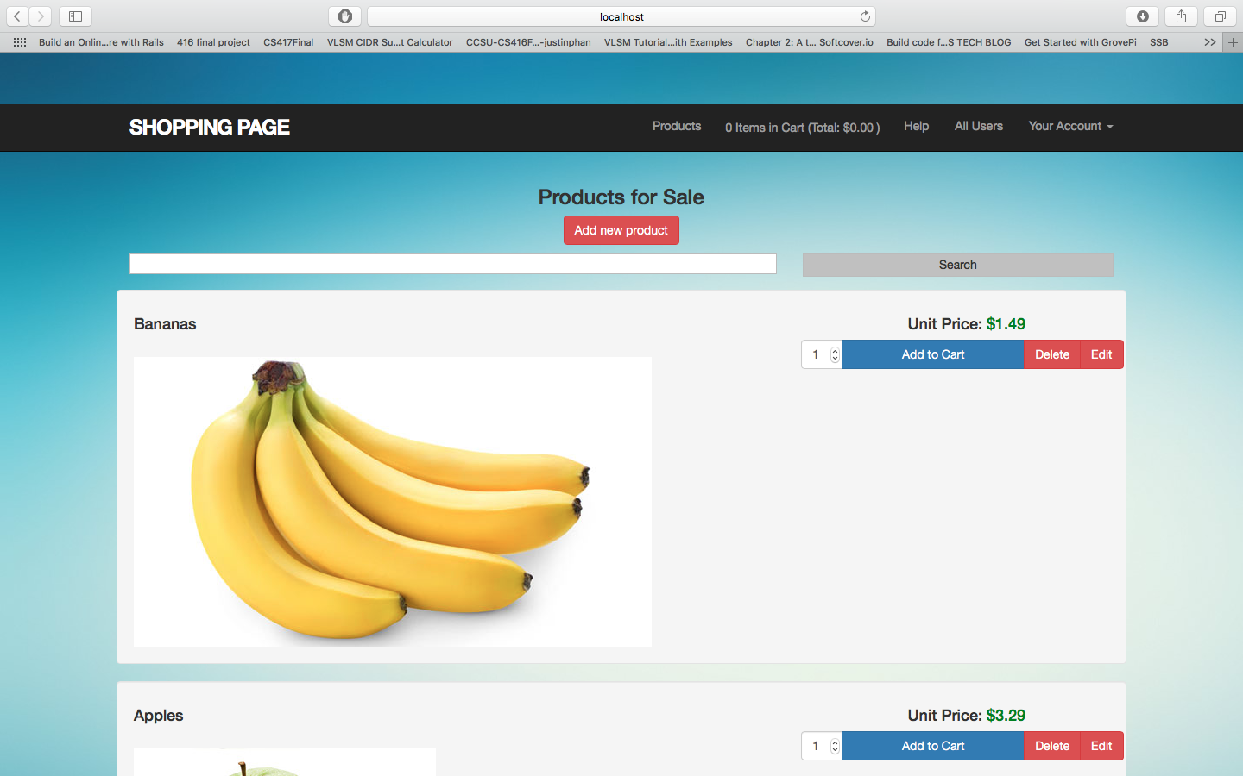

Add a product:

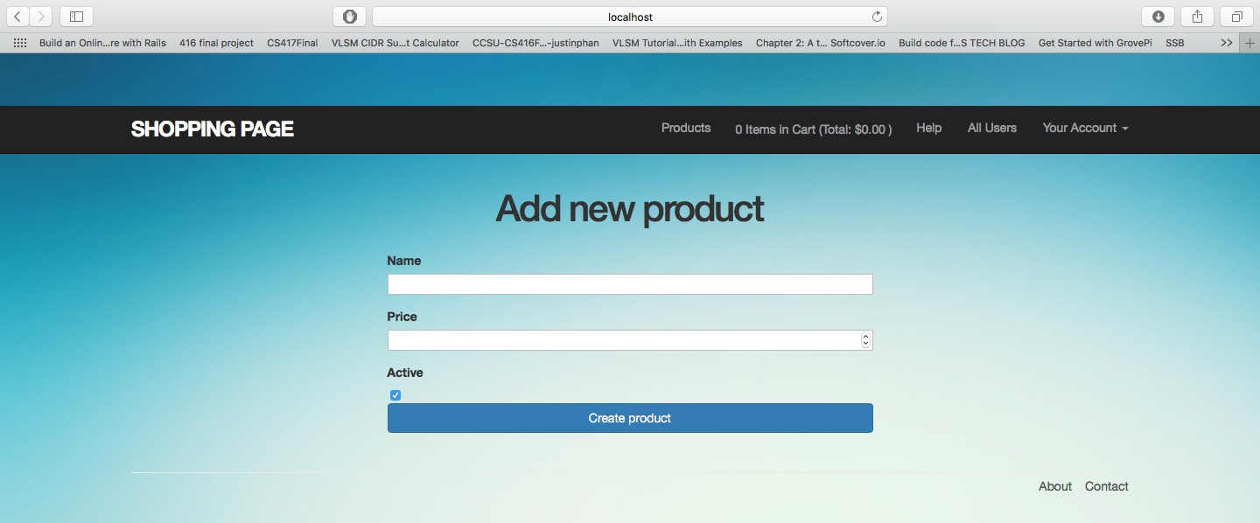

Edit a product: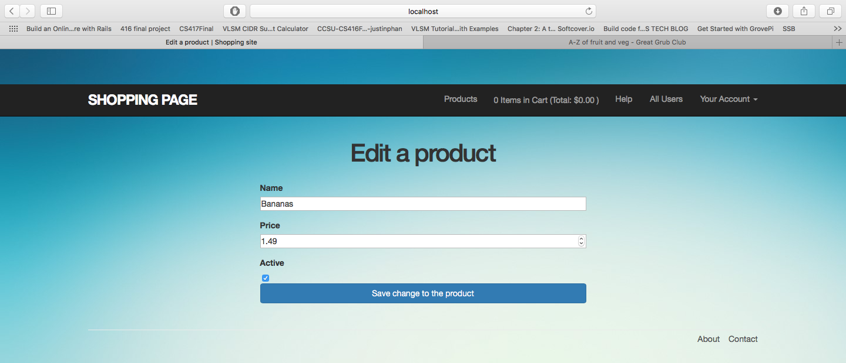

Views a list of user:

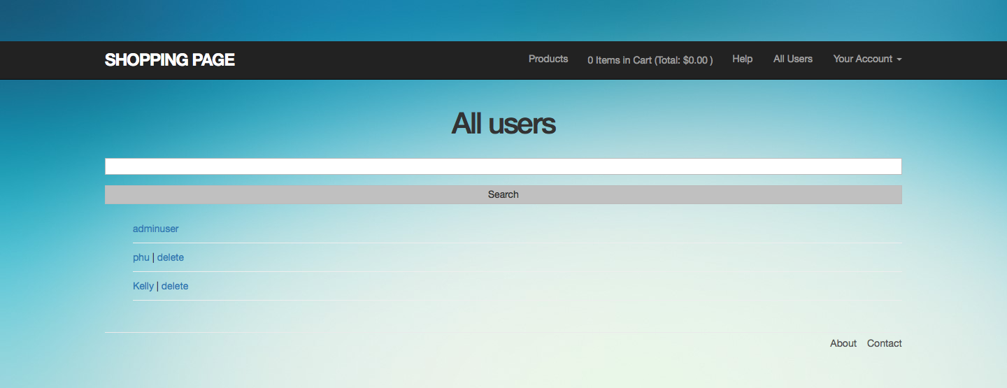

Delete a User:

